Types of ML

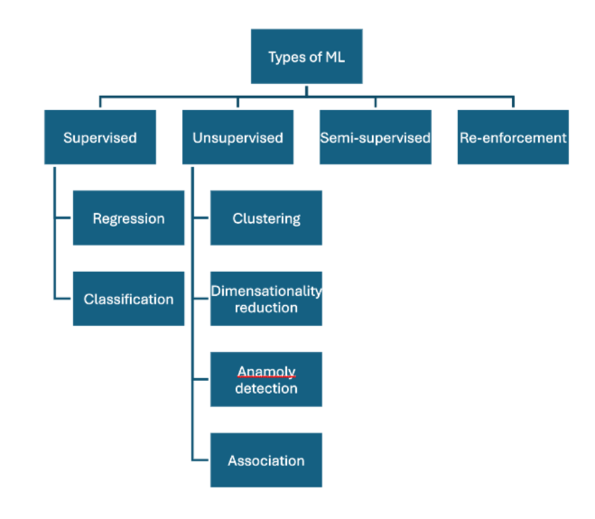

Supervised learning
Supervised learning is a type of machine learning where the model is trained on labeled data — meaning each input has a known correct output.
Key idea:
The algorithm learns a mapping from inputs XXX to outputs YYY such that f(X)≈Yf(X) ≈ Yf(X)≈Y.
Process:
- Provide labeled training data (input-output pairs).
- The model learns patterns linking inputs to outputs.
- Use the trained model to predict outputs for unseen inputs.
Types:
- Regression: Predict continuous values (e.g., house prices).
  - Handles numerical data (wight, marks, percentage etc)
- Classification: Predict discrete labels (e.g., spam or not spam).
  - Handles non-numerical data (texts, symbols)
Unsupervised learning
Unsupervised learning is a type of machine learning that works on unlabeled data, meaning the model is not given correct outputs.
Key idea:
The algorithm tries to find hidden patterns or structure in the input data XXX without knowing YYY.
Process:
- Input only unlabeled data.
- The model identifies groupings, similarities, or structure.
- Results are patterns or clusters, not explicit predictions.
Types:
- Clustering – Groups similar data points.
Algorithms: K-Means, Hierarchical Clustering, DBSCAN.
Use: Customer segmentation, document grouping.
- Dimensionality Reduction – Reduces number of features while retaining information.
Algorithms: PCA, t-SNE, Autoencoders.
Use: Data visualization, noise reduction, preprocessing.
- Anomaly Detection – Detects rare or unusual data points.
Algorithms: Isolation Forest, One-Class SVM, LOF.
Use: Fraud detection, fault detection.
- Association Rule Learning – Finds relationships between variables.
Algorithms: Apriori, Eclat, FP-Growth.
Use: Market basket analysis, recommendation systems.

Semi-supervised learning
Semi-supervised learning uses both labeled and unlabeled data for training — usually a small amount of labeled data and a large amount of unlabeled data.
Key idea:
It combines supervised and unsupervised learning to improve accuracy when labeling all data is costly or time-consuming.
Process:
- Train the model on labeled data.
- Use it to assign pseudo-labels to unlabeled data.
- Retrain using both labeled and pseudo-labeled data.

Reinforcement learning
Reinforcement learning (RL) is a type of machine learning where an agent learns to make decisions by interacting with an environment to maximize a reward.
Key idea:
The agent learns through trial and error using feedback (rewards or penalties), not labeled data.
Core elements:
- Agent – the learner or decision maker.
- Environment – everything the agent interacts with.
- Action (A) – what the agent can do.
- State (S) – the current situation.
- Reward (R) – feedback from the environment.
Goal:
Find an optimal policy (strategy) that maximizes cumulative reward over time.
Examples:
- Game playing (chess, Go, Atari).
- Robotics (navigation, control).
- Recommendation systems and resource optimization.

Batch learning vs Online learning

Batch learning
Batch learning is a training method where the model is trained on the entire dataset at once rather than updating continuously.
Key idea:
All data is collected, cleaned, and fed to the algorithm in one go. After training, the model is fixed until retrained with new data.
Characteristics:
- Requires all training data available beforehand.
- Computationally heavy.
- Model does not learn incrementally.
Use cases:
- Stable, large datasets.
- Periodic retraining (e.g., recommendation models updated monthly).
Disadvatages
- Lots of data
- Hardware limitation
- availability
Example:
Training a spam filter once on a full email dataset, then deploying it for predictions until next retraining.

Online training
Online learning is a machine learning approach where the model learns incrementally, updating itself each time new data arrives instead of retraining from scratch.
Key idea:
The model refines its parameters continuously as it receives data samples one by one or in small batches.
Characteristics:
- Works well with streaming or real-time data.
- Requires less memory and computation than batch learning.
- Adapts to changing data patterns (concept drift).
Advantages:
- Fast updates.
- Handles large or infinite datasets.
- Suitable for dynamic environments.
Disadvantages:
- Prone to noise and instability.
- May forget older patterns if not managed.
Examples:
- Stock market prediction.
- Real-time recommendation systems.
- Online fraud detection.
Common algorithms:
Stochastic Gradient Descent (SGD), Online SVM, Perceptron, Passive-Aggressive algorithms.

Wheather batch learning and onling learning useful or not it depends upon scenario of the usage.

INSTANCE BASED LEARNING VS MODEL BASED LEARNING

Instance based learning
- (the machine learns by memorizing the data)
- The algorithm stores training examples and makes predictions by comparing new data to stored instances.
- It does not build an explicit model; it relies on similarity measures (e.g., distance).
Examples:
K-Nearest Neighbors (KNN), Locally Weighted Regression.
Advantages:
- Simple, no training phase.
- Adapts easily to new data.
Disadvantages:
- Slow at prediction time.
- Memory intensive.
- Sensitive to noise.

Model based learning
- The algorithm builds a general model from the training data.
- It learns parameters that best fit the data and uses them for future predictions.
Examples:
Linear Regression, Decision Trees, Neural Networks.
Advantages:
- Fast predictions after training.
- Compact representation.
Disadvantages:
- Requires training time.
- May underfit if the model is too simple.
In short:
- Instance-based: learns by remembering.
- Model-based: learns by generalizing.

Feature | Instance-Based Learning | Model-Based Learning
Definition | Stores and uses training examples directly for prediction. | Builds a general model from data to make predictions.
Learning Approach | Memorizes data instances. | Learns parameters or functions to generalize patterns.
Training Phase | Minimal or none. | Involves explicit model training.
Prediction Time | Slow (must compare with many stored samples). | Fast (uses learned model).
Memory Usage | High — stores most or all training data. | Low — stores only model parameters.
Adaptability | Can easily add new data. | Needs retraining for new data.
Examples | K-Nearest Neighbors (KNN), Locally Weighted Regression. | Linear Regression, Decision Tree, Neural Networks.
Computation Focus | More at prediction time. | More at training time.
Handling Noise | Sensitive to noisy data. | Can generalize better and resist noise.
Output | Based on similarity to known instances. | Based on a learned mathematical model.

CHALLENGES IN ML

- Data collection
  - Either can collect through API or through Web scrapling
- Insufficient data / labelled data
  - Data is available most of the times, and sometimes they are not labelled (in random format)
- Non-representative data
  - Suppose you are trying to get an output from a given set of data, but what if that given set of data is half only remaining data not available, in that case you will get the output but it will not be a proper output (its incomplete)
- Poor quality data
- Irrelevant features (unrequired data)
- Overfitting
  - When a model memorizes the training data instead of learning the underlying patterns. It performs very well on the training data but fails to generalize to new, unseen data (when new data is added). This happens because the model has learned noise and specific details instead of true relationships.
- Underfitting
  - Underfitting occurs when a model is too simple to capture the underlying patterns in the data. It performs poorly on both training and test data.
- Software integration
- Batch learning / Deplayment
- Cost involved

ML DEPLOYMENT LIFE CYCLE (MLDLC / MLDC)

Its a set of guidelines that you have to follow when making of a project to finally deploying it.

There are different steps to do it ;
- Frame the problem
  - Properly evaluating the problem (each and everything of the problem)
- Gathering data
- Data pre-processing
  - Removing duplicates
  - Removing missing values
  - Removing outlyerss
  - Scaling the data
- Exploratory data analysis
  - Analysing the data
  - Analysing the relationship btwn datas
  - Doing visualizaion
  - Making graphs
  - Univariate analysis
  - Bi-variate analysis
  - Multi variate analysis
  - Outlyer detection
  - Balancing the data, etc
- Featuring engineering and selection
- Model training, evaluation, and selection
- Model deployment
- Testing
- Optimize

TENSORS

A tensor is nothing but a container that contains numerical data for computations, to be used in frameworks like TensorFlow and PyTorch.

0D scalar (0D tenser) -- 0 dimensional data
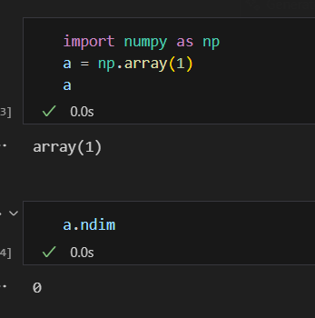

Element that store only 1 numerical data

1D tensor
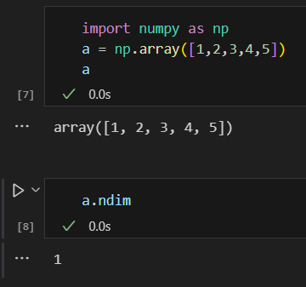

All these numbers are put on the x axis or y axis, bcoz it is 1D, hence it takes one axis only. This is also called a vector, now it will be called as 4D vector bcoz it holds 4 elements.

This above is a 1D tensor and as well as a 4D vector.

2D tensors

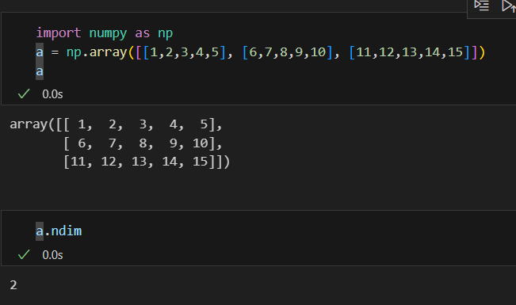

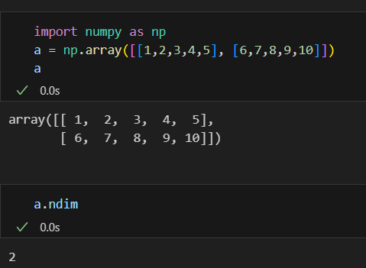

Both pick above are the example of 2D tensor.

3D tensor
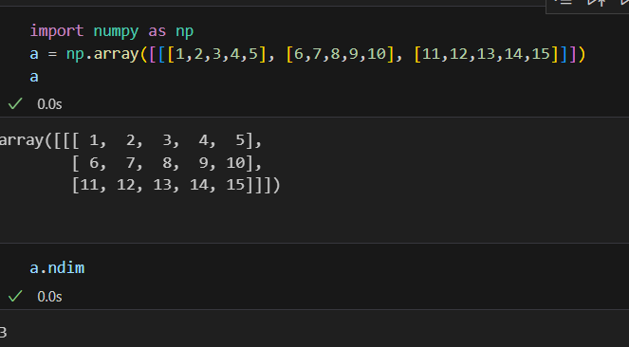

Same goes for the nD tensors

Rank, Axis, and Shape

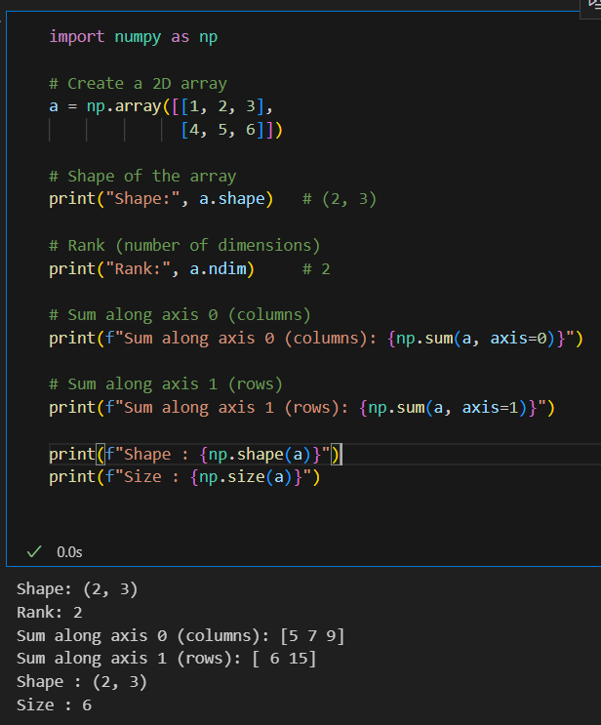

StandardScaler()

StandardScaler is a tool in machine learning that makes all your features (columns) have similar scale.

What it does ???

It changes your data so that:
- The average value becomes 0
- The spread of the data becomes 1

It centers the data around 0 and rescales it so all features are on a similar level.

Because features like CGPA and IQ may have very different ranges (for example, 0–10 vs 80–150). If we don’t scale them, the model might think the bigger-number feature is more important. StandardScaler fixes that problem.

Does this mean standardScaler sets the importance to the data ???

No, StandardScaler doesn’t set the importance of the data.

It only changes the scale (the size of the numbers),
not the meaning or importance of the data itself.

It makes sure that:
- Features with large numbers (like IQ = 120)
don’t overpower small-number features (like CGPA = 8).

But it doesn’t decide which feature is more important.
That’s what the model (like Logistic Regression, Decision Tree, etc.) figures out during training.

What is scaling ???

Scaling means changing the range or size of your data values so that all features are on a similar scale (level).

It doesn’t change what the data means —
it just adjusts the numbers so that no column has values much bigger or smaller than the others.

Why we scale data ???

- Models look at numbers to find patterns.
- If one feature has large values, the model may think it’s more important — even if it’s not!

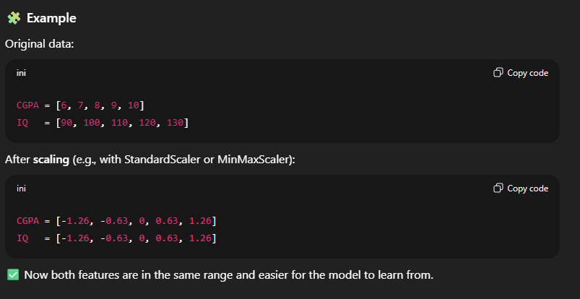
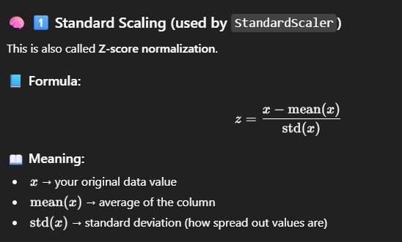
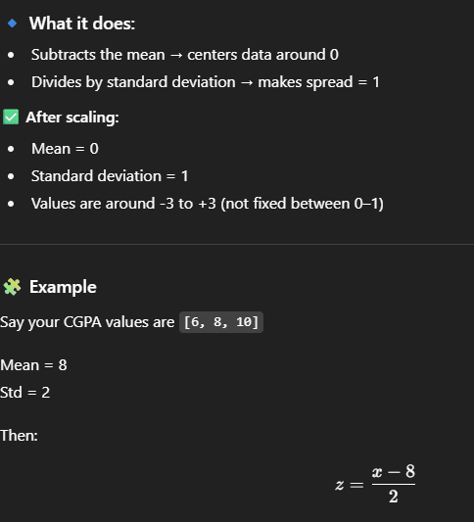

fit_transform()

fit_transform() is a method used in many sklearn tools (like scalers, encoders, and even models).
It’s basically a shortcut that does two things at once:
- fit() → learns something from your data (for example: mean, std, min, max, etc.)
- transform() → uses what it learned to actually change the data

fit_transform() = fit() + transform()

In the case of StandardScaler

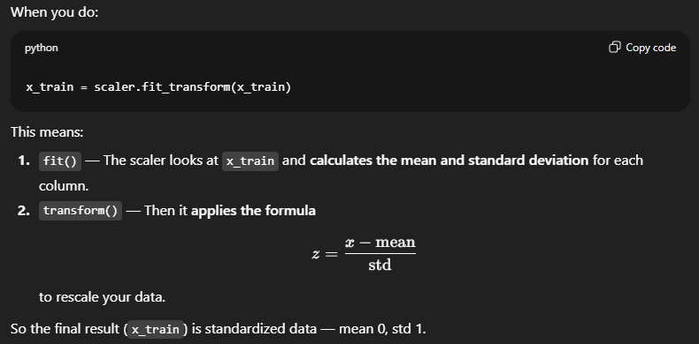
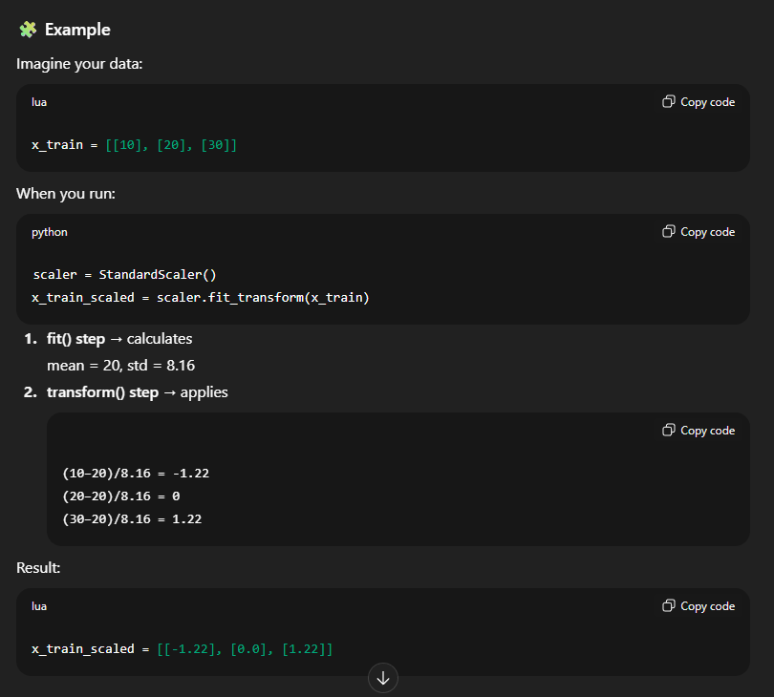

LinearRegression

Linear Regression is the simplest and most widely used algorithm in machine learning — especially for predicting continuous numerical values.
It finds the best straight line that fits the relationship between input (X) and output (Y).

P Testing

p-testing refers to hypothesis testing using the p-value to decide whether to reject a null hypothesis.
Core idea:

- You start with a null hypothesis (H₀), typically “no effect” or “no difference.”
- Compute a test statistic (t, z, χ², etc.) from your data.
- The p-value is the probability of obtaining a test statistic at least as extreme as the observed one, assuming H₀ is true.

Interpretation:

- Low p-value (≤ α) → reject H₀ → the result is statistically significant.
- High p-value (> α) → fail to reject H₀ → insufficient evidence against H₀.
- Common α (significance) level: 0.05.

Example:
If p = 0.02 and α = 0.05 → reject H₀ → there’s strong evidence that the effect is real.

What is null hypothesis ???
The null hypothesis (H₀) is the default assumption that there is no effect, no difference, or no relationship in the population being studied.

It serves as the baseline for statistical testing.
You test whether your data provides enough evidence to reject it.

Suppose you want to test if the feature “number of rooms” has a statistically significant effect on house price before including it in your regression model.

Normal Distribution

A normal distribution (also called Gaussian distribution) is a continuous probability distribution that is symmetric and bell-shaped around its mean.

- Mean = Median = Mode
- Defined by two parameters:
  - μ (mu): the mean (center)
  - σ (sigma): the standard deviation (spread)
- About 68% of data lies within ±1σ of the mean, 95% within ±2σ, and 99.7% within ±3σ.

Bi-modal Distribution
A bimodal distribution is a probability distribution with two distinct peaks (modes) in its frequency or probability curve.
It indicates the data come from two different underlying groups or processes.

Example:
If you plot heights of people in a dataset that includes both adult men and women, you might see two peaks — one near the average female height and one near the average male height.

Formally:
- Unimodal → one peak (e.g., normal distribution)
- Bimodal → two peaks
- Multimodal → more than two peaks

Detection:
You can identify it visually with a histogram or density plot, or numerically by checking for multiple local maxima in the distribution.

How a bimodal distribution affects the mean, median, or standard deviation ???
Bimodal distribution has two peaks, so its summary statistics behave differently than a unimodal (single-peaked) one:

- Mean – Lies between the two modes, often not representative of the dataset. It can be pulled toward the larger peak.
- Median – Also between the two modes. Like the mean, it may fall in a region with few data points.
- Standard Deviation – Usually larger because data are spread around two centers instead of one, increasing variability.
Strong Number

A Strong number (also called a factorion) is a number equal to the sum of the factorials of its digits.

Check if 145 is a strong number:
1!+4!+5! = 1+24+120 = 145 [yes 145 is a strong number]

Can every number be a strong number ???
Only a few specific numbers are strong numbers because the factorial function grows very fast. After a certain point, the sum of factorials of digits can never catch up with the number itself.

Confidence Interval (CI)

A confidence interval (CI) is a range of values that estimates where a population parameter (like the true mean) is likely to fall, based on sample data.

How CI is different from mean ???
The mean is a single point estimate — the average of your sample data.
The confidence interval (CI) is a range around that mean showing the uncertainty of the estimate.

Is CI related to mean only, or it is related to any other parameter as well ???
CI is related to any parameter, not just the mean.
- Mean CI → range for the true average.
- Variance or Standard Deviation CI → range for how spread out data are.
- Regression Coefficient CI → range for model parameter estimates (in ML or stats).

Correlation

Correlation measures how strongly two variables/ features/columns are related to each other.
It’s expressed by the correlation coefficient (r), which ranges from –1 to +1.

Types;
- Positive correlation (r > 0)
  - As one variable increases, the other increases.
  - Example: height vs. weight.
- Negative correlation (r < 0)
  - As one variable increases, the other decreases.
  - Example: price vs. demand.

- Zero correlation (r = 0)
  - No linear relationship between the variables.
  - Example: shoe size vs. IQ.

A/B Testing

A/B testing is an experiment used to compare two versions of something (A and B) to see which performs better.

Example;
- Website UI:
  - Version A shows a blue “Buy” button.
  - Version B shows a green “Buy” button to test which gets more clicks.

- Email marketing:
  - Email A uses the subject “Limited Time Offer!”.
  - Email B uses “Save 20% Today Only!” to see which one gets more opens.

- Mobile app onboarding:
  - Version A shows a 3-step tutorial.
  - Version B shows a 1-minute video guide to test which improves user retention.

- Ad campaign:
  - Ad A uses a photo of the product.
  - Ad B uses a video demonstration to compare click-through rates.

- Pricing test:
  - Page A offers a $10 monthly plan.
  - Page B offers a $100 yearly plan (2 months free) to see which converts better.

- Recommendation system:
  - Model A recommends trending items.
  - Model B recommends personalized items to test which drives more engagement.

Suppose a model has a very r2_accuracy value, but after implementating it doesnot percorm well in real world. What can be the possible reasons for it ???

- Overfitting
- Data leakage - Data leakage occurs when information from outside the training dataset leaks into the model during training, giving it an unfair advantage.
- Poor data quality / Data drift
- Improper train_test_split / cross validation
- Less data or Unbalanced data
- Changes in real world conditons

Regression vs Decision Tree in ML

Regression, particularly Linear Regression, is a parametric model that assumes a linear relationship between the input variables (features) and the output (target). It works best when data follows a roughly straight-line pattern, meaning as one variable increases or decreases, the other does so proportionally. The model tries to fit the best straight line through the data points using an equation of the form. Linear regression is easy to interpret since each coefficient shows how much the output changes for a unit change in each input variable. However, it struggles with nonlinear data, outliers, and cases where relationships are complex or not strictly linear. It’s mainly used in tasks like predicting house prices, sales, or other continuous values.

Decision Trees, on the other hand, are non-parametric models that do not assume any specific mathematical form of the data. Instead, they work by splitting the dataset into smaller subsets based on feature values, creating a tree-like structure of decisions. Each internal node represents a condition on a feature, each branch represents the outcome of that condition, and each leaf node gives a final prediction. Decision Trees can capture complex, nonlinear relationships and handle both numerical and categorical variables (for textual categorical data you have to use encoders). However, they are prone to overfitting, especially if the tree grows too deep, and can be sensitive to small changes in data. Despite this, they are powerful for modeling real-world problems like predicting loan defaults, customer churn, or medical diagnoses.

In summary, Regression models are simple, fast, and interpretable but limited to linear patterns, while Decision Trees are flexible and powerful for capturing complex relationships, but prone to overfitting. Regression gives a smooth global trend (a straight line), whereas Decision Trees divide the space into regions, adapting to data irregularities. Choosing between the two depends on whether your data follows a simple linear trend or exhibits more complex, nonlinear behavior.

What is parametric and non-parametric ???
Parametric models are those that assume a fixed mathematical form or relationship between input (X) and output (Y).
They have a fixed number of parameters that do not depend on the size of the dataset.

Non-parametric models do not assume any specific mathematical form for the relationship between X and Y.
They learn patterns directly from the data, and the number of parameters can grow with the size of the dataset.

When to use regression and When to use decision tree ???
Choosing between Regression and Decision Tree models depends largely on the nature of the data, the type of relationship between variables, and the goal of the analysis.

Regression models (such as Linear Regression or Logistic Regression) are best suited when the relationship between independent and dependent variables is approximately linear. If a change in one variable consistently increases or decreases the outcome, regression is appropriate. These models are also highly interpretable, as they clearly show how much each feature contributes to the prediction. Regression performs well on smaller datasets, requires numeric and clean data, and is ideal when assumptions like normality and independence are met. For example, when predicting house prices based on size or experience-based salary prediction, regression often gives strong, interpretable results.

Decision Trees, on the other hand, are more flexible and do not assume a linear relationship. They are well-suited for problems where the relationships between variables are complex or nonlinear. Decision Trees can easily handle both numerical and categorical data and are robust to missing values and outliers. They are also excellent for modeling interactions between variables and for creating interpretable rule-based logic such as “If age < 30 and income > ₹50,000, then loan approved.”

Precision and Recall

In classification problems, especially in imbalanced datasets (where one class [spam or non-spam for mail] occurs much more often than another), simple accuracy is not enough to measure model performance. Instead, we use Precision and Recall, two key metrics that help evaluate how well a model identifies positive cases.

Recall
Recall measures how many of the actual positive cases the model successfully identified.
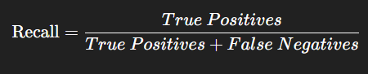
If there were 200 patients who truly had the disease, and your model correctly identified 80 of them, then Recall = 80 / 200 = 0.4 (or 40%).

Precision
Precision measures how many of the predicted positive results are actually correct.
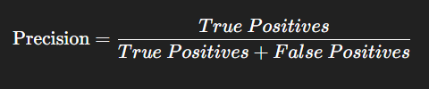
If your model predicted 100 patients as having a disease and only 80 of them actually had it, then Precision = 80 / 100 = 0.8 (or 80%).

Precision-Recall Tradeoff
There is a trade-off between Precision and Recall — improving one often reduces the other.
This happens because both depend on the classification threshold (the score above which a prediction is labeled “positive”).

- If you increase the threshold, the model becomes more conservative — it only predicts “positive” when very sure.
  - Precision increases, but Recall decreases (you miss some actual positives).
- If you lower the threshold, the model becomes more lenient, marking more items as “positive.”
  - Recall increases, but Precision decreases (you get more false alarms).

Example
Spam Email Filter
- High Precision → Only marks real spam, but some spam emails may slip through (low recall).
- High Recall → Catches all spam, but may also mark important emails as spam (low precision).

Is there any way i can set importance on features while using regression ??

There are ways to control or adjust the importance of features when using regression models, but the method depends on what kind of regression or situation we are dealing with.

While using Linear Regression
In ordinary least squares (OLS) regression, feature importance is not directly set by you — it’s learned automatically based on how much each feature helps reduce the error.

Still we can influence the feature importance indirectly.
- Feature scaling: Standardizing features ensures that coefficients are comparable and not biased toward features with larger numeric ranges.
- Feature selection: You can remove less important features using statistical tests (like SelectKBest, RFE, etc.).
- Adding polynomial terms or interactions: You can increase the weight of certain relationships manually if you know they matter.

While using Regularized Regression (Ridge, Lasso, ElasticNet)
- Lasso Regression (L1 Regularization)
    - Lasso shrinks some coefficients exactly to zero, removing unimportant features.
    - This automatically performs feature selection.
- Ridge Regression (L2 Regularization)
    - Ridge reduces the magnitude of all coefficients, making the model less sensitive to unimportant features but keeps all features.
- ElasticNet
    - Combines both Lasso and Ridge — lets you balance between shrinking and removing features.

Manually weighting feagures
If we alredy know some features are important in the data set, then we can multiply those features by a weighting factor before training.
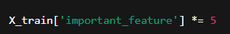
However, be careful: this is not a statistically robust method — use it only when domain knowledge clearly supports it.
the number 5 is an arbitrary weighting factor — it means “multiply this feature’s values by 5 to make it 5 times more influential” in the regression model.

Using Model Interpretation after Training
We can also determine feature importance after training using:
- Coefficients in linear models (model.coef_)
- Permutation importance (sklearn.inspection.permutation_importance)
- SHAP values (SHapley Additive exPlanations)

How you can asses importance of a particular feature ???
When using regression models
  - Each feature gets a coefficient (coef_ in sklearn).
  - A larger absolute value → stronger influence on the prediction.
  - A positive coefficient → increases the target.
  - A negative coefficient → decreases the target.

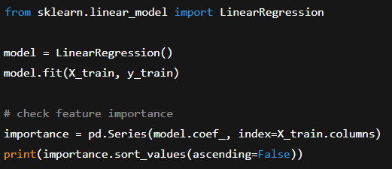

When using tree based models
Tree models automatically calculate feature importance scores during training.
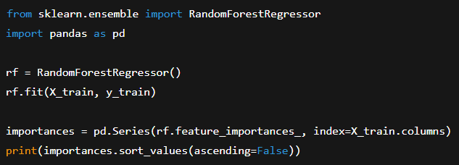

When using permutation
This method works with any model — regression, trees, neural networks, etc.
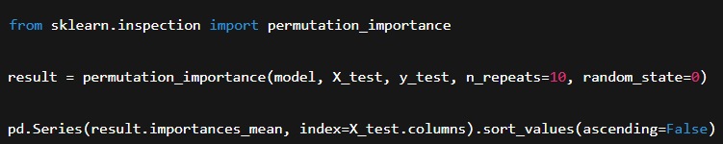

When using SHAP
SHAP values explain the contribution of each feature to individual predictions — the most powerful and interpretable modern method.
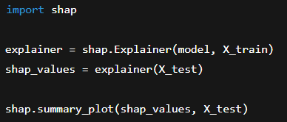

What are the assumptions of LinearRegression ???

- Linearity – The relationship between independent and dependent variables must be linear.
Check: Residual plots should show no curve.
- Independence of Errors – Residuals must be independent of each other.
Check: Durbin–Watson test (ideal ≈ 2).
- Homoscedasticity – The variance of residuals should be constant across all levels of X.
Check: Residuals vs fitted plot (no funnel shape).
- Normality of Residuals – Residuals should follow a normal distribution.
Check: Q–Q plot or histogram (bell shape).
- No Multicollinearity – Independent variables shouldn’t be highly correlated. Input features must be independent of each other.
Check: VIF < 10.
- No Measurement Error – Independent variables should be accurately measured.
Fix: Improve data collection or use robust models.

Why multicollinearity is a problem ???
- Unstable coefficients – The model struggles to decide which variable is actually affecting the target. Small data changes can cause large swings in coefficient values.
- Reduced interpretability – It becomes hard to know which variable is really important since both convey the same information.
- Inflated standard errors – This makes coefficients appear statistically insignificant even if they are relevant.
- Poor generalization – The model may fit training data well but perform poorly on new data (overfitting risk).

How to know the features are correlated with each other ???
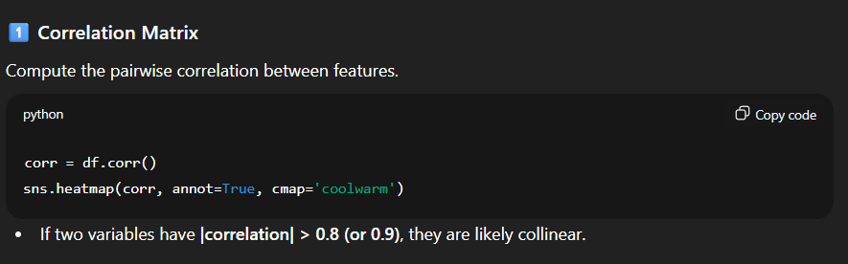

- Life cycle of Data Science ???
Explaining all the states we have to do while training a model.
- When you are working in a startup and the data is not available to train or to predict, how to approach ??
  - Domain knowledge needed
  - Data scrapping can be a solution
- How to know how the available data is sufficient or not ?
- How to handle a column which has many missing values ?
  - Mean, median, mode
  - KNN
  - Imputation
  - By removing rows or by removing entire column (only if too much data is missing)
- As working in team, how you are supposed to divide the work btwn the members ?

